Interconnection Guide for PIMS and vetXpert Public Cloud

- This Guide Covers Only PIMS-Active Animal Sample Data Push to vetXpert

- System Connection Diagram
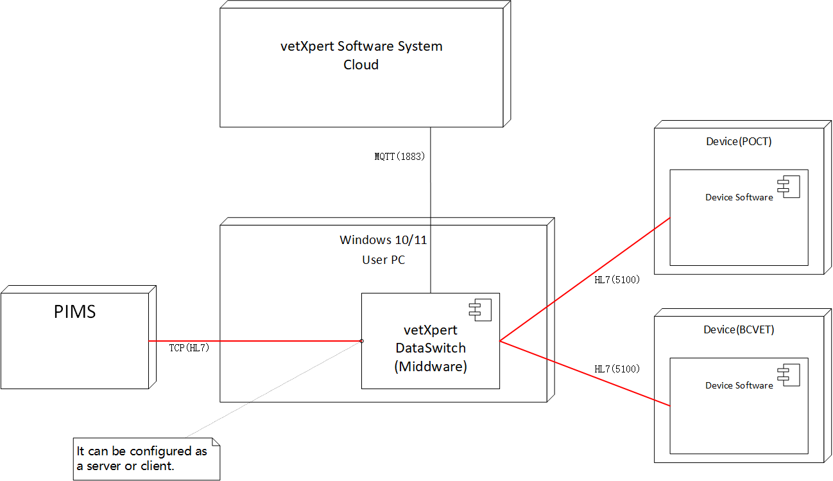

- System Interaction Diagram
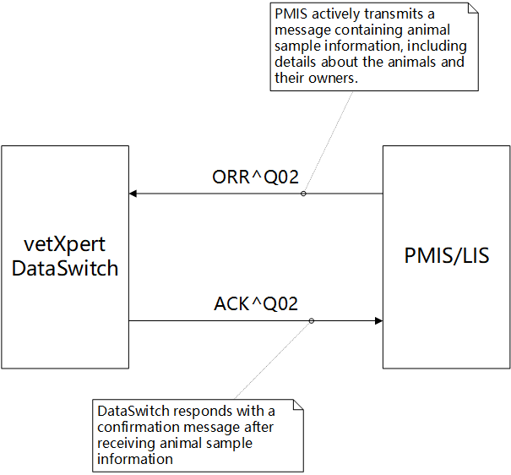

- PIMS Settings
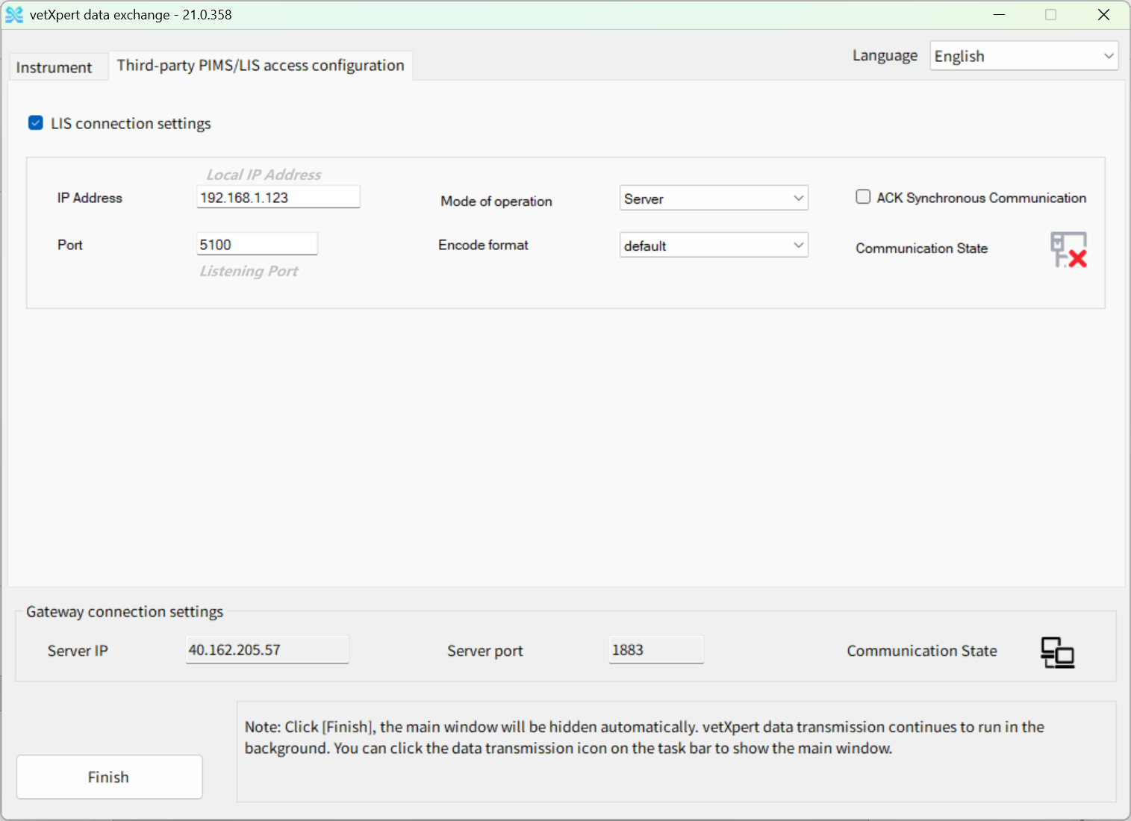
Notes: If the Model of operation selected “Server”, please set the IP address to IP address of the local computer where the DataSwitch software is installed.
- Instrument Setup
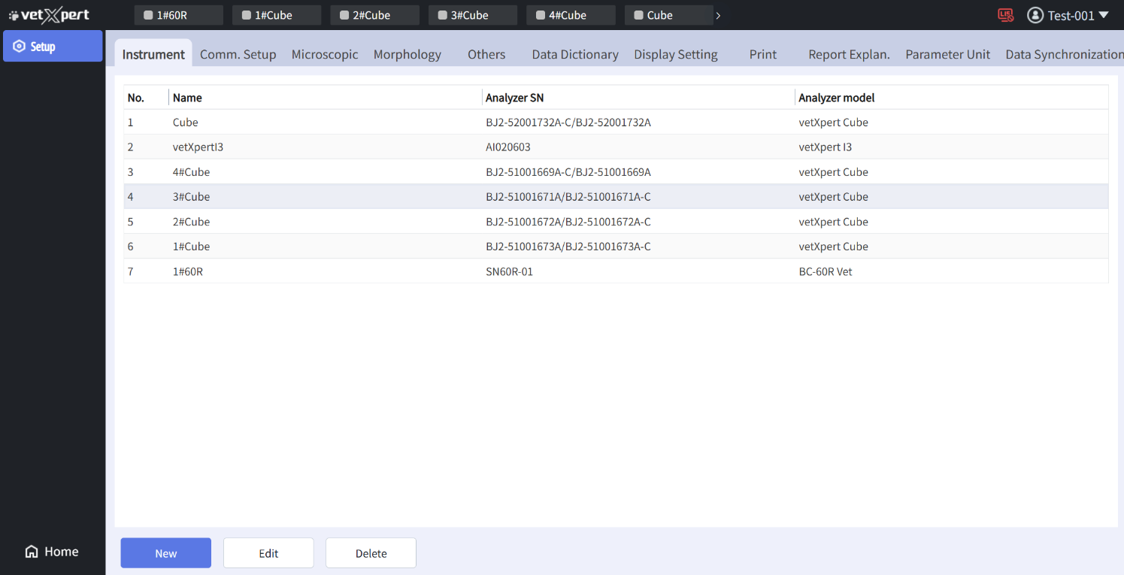
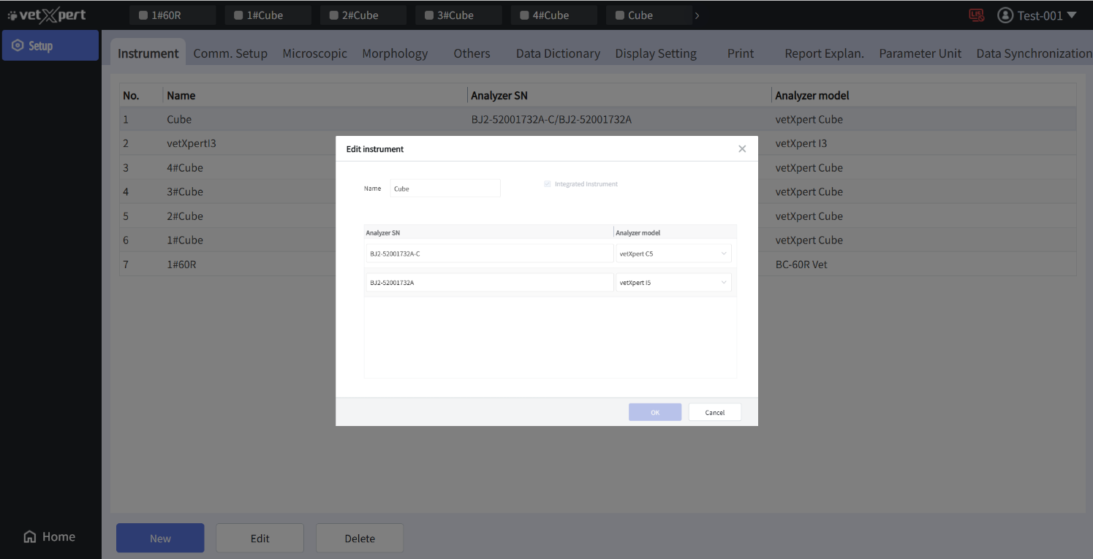

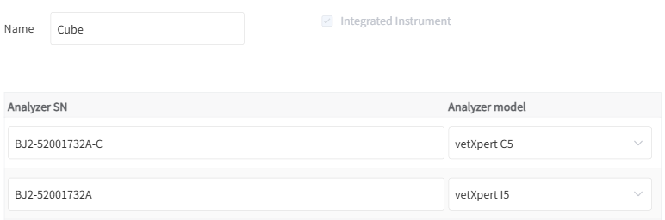

- Protocol Message Definition

ORR^O02 message：Complete Animal Sample Information。
ORR^O02 General Order Response Message Description
MSH Message Header
MSA Message Acknowledgment
[PID Animal Information
[PV1]] Veterinary Medical Records
{
[
OBR Sample Information
{[OBX]} Additional Sample Metadata Fields. Including the serial number of the instrument used, etc.
]
}
Table 1 MSH Field Definition Table
Index | Field Name | Data Type | Maximum Recommended Length | Description | Example
1 | Field Delimiter | ST | 1 | The first field delimiter after the message segment name, which defines the delimiter value for the remaining part of the message. | |
2 | Encoding Characters | ST | 4 | Includes component separator, repetition separator, escape separator, and subcomponent separator. | ^~\&
3 | Sending application | EI | 180 | Sending Application | Zilong
4 | Sending Facility | EI | 180 | Sending Device | PIMS
7 | Date/Time Of Message | TS | 26 | Message Creation Time (format: YYYY[MM[DD[HH[MM[SS]]]]]), derived from system time. | 20101012092538
9 | Message Type | CM | 7 | Message Type (format: MessageType^EventType) | ORR^O02
10 | Message Control ID | ST | 20 | Message Control ID (unique identifier for a message) | 1
11 | Processing ID | PT | 3 | Message Processing ID (values:  P-Sample/worksheet query information;  Q-Quality control counting result;  T-System time query message;  A-Actively pushed message;  In Ack messages, it matches the received message.) | A
12 | Version ID | VID | 60 | HL7 Version (value: '2.3.1') | 2.3.1
18 | Character Set | ID | 10 | Character Set (value: 'UNICODE' – messages are UTF-8 encoded) | UNICODE

Table 2 MSA Field Definition Table
Index | Field Name | Data Type | Maximum Recommended Length | Description | Example
1 | Acknowledgment Code | ID | 2 | Acknowledgment Codes：  AA (Application Accept)，  AE (Application Error)，  AR (Application Reject)，  AS (Application Skip) | AA
2 | Message Control ID | ST | 20 | Message Control ID, identical to MSH-10 in the corresponding received message. | 1

Table 3 PID Field Definition Table
Index | Field Name | Data Type | Maximum Recommended Length | Description | Example
1 | Set ID - PID | SI | 4 | Sequence number, used to identify different PID segments within a single message. | 1
3 | Patient Identifier List | CX | 26 | In sample messages, serves as the medical record number, formatted as 'MRN^^^^MR'. | C1^^^^MR
5 | Patient Name | XPN | 48 | Name (divided into pet name, owner name, and owner telephone number), formatted as AnimalName^OwnerName^Telephone. | Wang Cai^Zhang Sheng^10086
8 | Sex | IS | 1 | Gender, string type. Matches the display string on the user interface. | Male

Table 4 OBX Field Definition Table
Index | Field Name | Data Type | Maximum Recommended Length | Description | Example
1 | Set ID - OBX | SI | 10 | Sequence number, used to identify different OBX segments within a message. | 8
2 | Value Type | ID | 3 | Test result data type, with possible values including 'ST', 'NM', 'ED', 'IS', etc. Refer to Appendix B for details. | NM
3 | Observation Identifier | CE | 590 | Data item name identifier. | 30525-0^Age^LN
5 | Observation Value | * | 65535 | Data item value, which can be a number, string, enumerated value, binary data, etc. For specific value formats, refer to Appendix C. | 15
6 | Units | CE | 60 | Units. Uses HL7-defined standard unit notations. Refer to Appendix C for all units used in communication. | yr
11 | Observ Result Status | ID | 1 | Value is 'F'. | F

Table 5 Data Item Definition Table
Data Item | Data Type  (OBX-2) | Encoding (ID) | Name | Encoding Systems（EncodeSys） | OBX-3  Field Examples
Others Data Item
Age | NM | 30525-0 | Age | LN | 30525-0^Age^LN
Age Groups | IS | 30525-1 | Age Group | LN | 30525-1^Age Group^LN
Remarks | ST | 01001 | Remark | 99MRC | 01001^Remark^99MRC
Animal Species | IS | 01003 | Species | 99MRC | 01003^Species^99MRC
Instrument Serial Number | ST | 09003 | SN | 99MRC | 09003^ SN ^99MRC

Table 6 Coded Value Table
Data Item | Enumeration Values
Animal Species (Species) | Value enumeration:  “720” – Dog  “721” - Cat  “722” - Horse  “723” - Rat  “724” - Mouse  “725” - Rabbit  “726” - Monkey  “727” - Pig  “728” - Camel  “729” - Goat  “730” - Ferret  “731” - Cow  “732” - Sheep  “733” - Llama  “734” – Panda  “735” – Red Panda  “736” – Guinea pig  “737” – Alpaca  “738” – Dolphin  “739” – Whale  “740” – Avian  “741” – Fish  “742” – Reptile  “743” – Amphibian  “744” – Deer  “745” – Elephant  “746” – Gerbil  “747” – Hamster  “748” – Minipig  “749” – Seaturtle  “750” – Tortoise  “751” – Lizard  “752” – Snake  “753” – Cattle
Age Groups（Age Group） | Valid values:  "Child" → Childhood  "Adult" → Adulthood  "Old" → Elderly  "Unknown" → Unknown (default if not specified)
Gender | Valid values：  “M”/“m”: Male  “F”/“f”: Female  “U”/“u”: unknow  “N”/“n”:Neutered  “S”/“s”:Spayed  Other Content: Process directly as display strings
Age Units | Valid values：  “Yr” -Year  “mo” -Month  “d” -Day  “hr” -Hour  “wk” -Week

- Message Payload Demo
Animal sample information to be transmitted is as follows:
Medical Record Number：202501
Sample ID：17
Animal Type：Cat
Gender：Female
Age：6 Years Old
Age Group：Geriatric
Pet Name：Kitty
Owner Name：Trump
Phone Number：13631619220
Attending Veterinarian：Director Zhang
Laboratory Veterinarian：Dr. Li
Remarks：Test Notes
Laboratory Equipment Serial Number：SN60R-01

The corresponding transmission of animal sample reports via ORR^O02 message is as follows:
MSH|^~\&|Zilong|PMIS|||20250318172212||ORR^O02|16|A|2.3.1||||||UNICODE
MSA|AA|16||||
PID|1||202501^^^^MR||Kitty^Trump^13631619220|||Female
OBR|1||17|||||||Director Zhang||||||||||||||||||||||Dr. Li
OBX|1|NM|30525-0^Age^LN||6|yr|||||F
OBX|2|ST|01001^Remark^99MRC||Test Notes||||||F
OBX|3|IS|30525-1^Age Group^LN||Old||||||F
OBX|4|IS|01003^Species^99MRC||721||||||F
OBX|5|IS|09003^SN^99MRC||SN60R-01||||||F

The responding ACK^O02 message from vetXpert is as follows:
MSH|^~\&| | |||20230318182324||ACK^O02|16|P|2.3.1||||||UNICODE
MSA|AA|16||||0

- Special Notes
Regarding the transmission of laboratory instrument serial numbers: Since a single veterinary hospital may have multiple Mindray veterinary instruments (e.g., hematology analyzers, biochemistry analyzers), and a single animal sample may require simultaneous testing (e.g., immunology and CBC), the PIMS (Practice Information Management System) must specify which instrument(s) should be used for testing. The instrument’s serial number can be viewed in VetXpert under: [System Configuration] → [Instrument Settings].

Supported in PIMS: Specifying Multiple Devices for Testing in a Single Request. The corresponding HL7 message example is as follows:
OBX|5|IS|09003^SN^99MRC||MJ2-52001732A^MJ2-52001732A-C||||||F

Complete Communication Protocol See《HL7 Communication Protocol for vetXpert.doc》.

